**Saucerman Lab guidelines for making scientific figures**

**Last updated: 12/4/2014 by JS**

Figure design is a central aspect of scientific communication, but most students learn to develop figures by a trial and error process that often does not lead to satisfactory results. In this document we’ll try to outline best practices and workflows, along with providing codes that ease figure generation. This is expected to be a living document, updated and improved as needed by all lab members.

**Common problems with scientific figures:**

1. Fonts are too small
2. Lines are difficult to discriminate
3. Labels are unclear and inconsistent
4. Figure elements are not uniformly sized and aligned
5. Colormaps used inappropriately

**MATLAB plot gallery**

*figureFormatting.m:* Applies various standards.

Figure sizes. 3.5” for 1 column, 5” for 1.5 column and 7.2” for 2 column figs.

Axis formatting. Tick Out, minor ticks on, box off.

Fonts: 8 pt font, Helvetica.

Lines: 0.5 pt for axes etc., 2 pt for data lines

Note if we change default sizes we’ll need to readjust line wdiths/fonts.

*barplot_gallery.m*

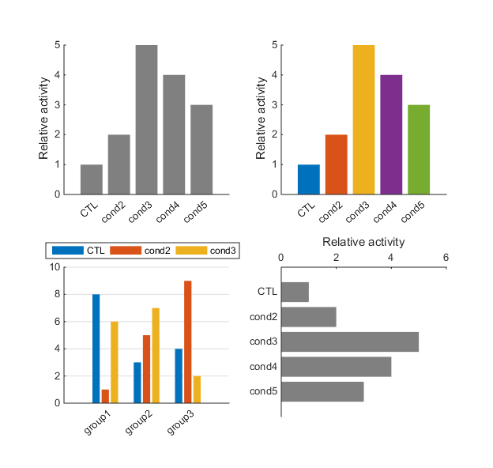

*boxplot_gallery.m*

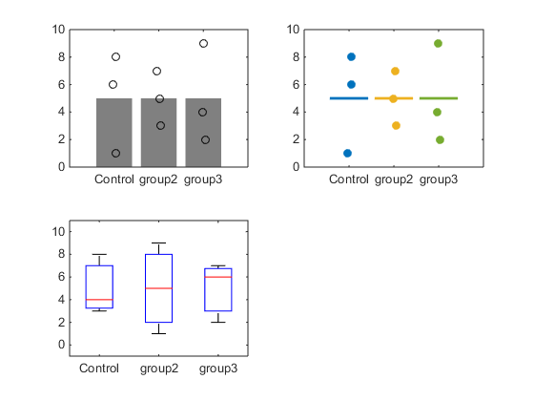

*plotAnnotations_gallery.m:* error bars, arrows, plot shading, annotation bars

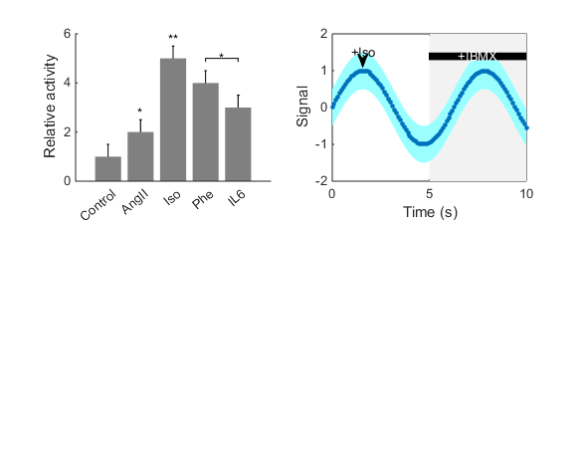

*scatterplot_gallery.m*: symbol types, line colors and widths

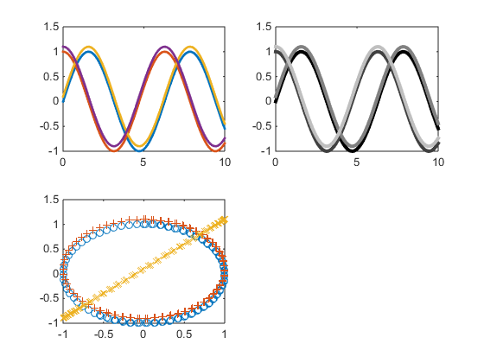

MATLAB’s plot gallery: http://www.mathworks.com/discovery/gallery.html

MATLAB Figure tips:

Note: the figure gallery uses the new object oriented graphics commands from MATLAB 2014b. Would require modifications to use the ‘set’ command more often for earlier versions. Overview of MATLAB graphics changes here: http://www.mathworks.com/products/matlab/matlab-graphics/

Figure panel assembly: Use Tools>Snap to Layout Grid to position panels and size figures.

To do: heatmaps- single and 2 directional. Legends. Text labels on lines in annotations

Suggestions:

**Workflow for generating figures:**

I primarily recommend MATLAB for initial figure generation, which allows scripting, autogeneration of figures and retains the original data. I recommend Inkscape for subsequent figure formatting and assembly.

MATLAB to Inkscape: Save as PDF, import PDF with fonts. Save in Inkscape as PDF or PNG.

Save your MATLAB FIG files, as the raw data it contains can be extracted for later analysis.

MATLAB to Powerpoint: Save as EMF or use Copy Figure with Edit>Copy Options>Metafile selected. This allows you to edit and manipulate the figure within Powerpoint for animations etc.

Images manipulated in ImageJ, saved as TIFF.

Network diagrams created in Cytoscape in a manner consistent with Activity Flow SBGN. See the sbgn props file in Netflux. Save as SVG for import into Inkscape.

**Inkscape Tips**

Import: PDF works very well

Export: PDF or SVG preferred for vector, PNG for bitmap. Can convert PNG to TIFF in ImageJ if needed.

**Web Resources:**

Points of View series from Nature Methods. Excellent and essential reading!! Provide many examples and considerations from a scientifically trained graphic artist, used in creating plot gallery guidelines.

http://blogs.nature.com/methagora/2013/07/data-visualization-points-of-view.html?WT.mc_id=TWT_NatureMethods

Nice short article on overview of graphic design principles for figures

<http://onlinelibrary.wiley.com/doi/10.1002/adma.201102518/full>

Very nice workflow involving R, inkscape, and imagej, much like mine! Lots of good details about figures

<http://cellbio.emory.edu/bnanes/figures/>

**Journal formatting guidelines:**

JBC: <http://www.jbc.org/site/misc/ifora.xhtml>

JMCC: <http://www.elsevier.com/journals/journal-of-molecular-and-cellular-cardiology/0022-2828/guide-for-authors#60002>

Circ Research: <http://circres.ahajournals.org/site/misc/aha_fig_tab_guidelines.pdf>, <http://circres.ahajournals.org/site/misc/ArtGuidelinesCircRes.pdf>

Nature: <http://www.nature.com/nature/authors/gta/#a5.9>